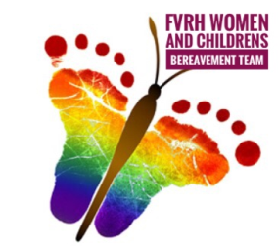 Application for memory tree leaf.

Thank you for getting in touch to request a leaf for our memory tree, please can you fill in the form below and send a copy back to us.
Name and address

Telephone number

Email address

Inscribing details for leaf
(Name and date)

Once we receive your application we will arrange for your leaf to go to the jewellers for inscribing, it can take a few weeks for this to be returned to us.
Once we have your leaf we will contact you to arrange collection.
Your leaf may stay on the memory tree for a year after this the Bereavement team will remove it and contact you for return so that you may keep this as an everlasting memento.
*If you would like your leaf returned prior to it being on the tree a year please contact the bereavement team for this to be arranged.
**Please advise us if any of the above contact details change so that we can ensure your leaf is safely returned to you.
For Bereavement team use
Date taken to Jewellers | Date returned from Jewellers | Date applicant contacted | Date given to applicant | Date returned to applicant

