Investing in Health
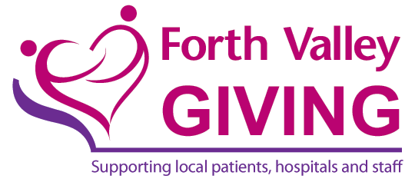
Small Grant Application Form

Your Details
Name:
Designation:
Organisation:
Address: |  |  | Telephone:
 |  |  | E-mail:
Are you a registered Charity? YES / NO  Charity No. - |  |  | Are you a not for profit organisation? YES / N0
Project details
Project title:
Please provide a brief summary of your project:

Proposed start date: |  |  |  | Proposed finish date:
Project Costs – please provide details of the total costs of the project
1) |  |  |  |  | £
2)
3)
4)
5)
6)
Total project costs |  |  |  |  | £
Project funding
How much funding are you requesting from Just Giving? |  |  |  |  | £
How much funding have you secured from other sources? – please provide details  (External grant applications which do not contain an element of match funding will not be considered).  1)  2)  3)  4) |  |  |  |  | £
Total funding from other sources |  |  |  |  | £
Total Project Funding |  |  |  |  | £
Exit Strategy
Forth Valley Giving will only provide funding for the first year of the project. What will happen to the project at the end of this first year?

Project beneficiaries
Who are the main beneficiaries of your project? i.e. mental health patients, elderly people, specific wards or departments, geographical area (local community or all Forth Valley population etc.), Please also indicate if possible the approximate number of beneficiaries of your Project.

NHS applications only – additional information required
Grants must be for direct patient benefit or staff educational opportunities and may not be utilised to substitute for core services that the Health Board would normally be expected to provide.
Please provide details of why this activity should not be considered a core service:

Please provide any additional information on a separate sheet.

We, the undersigned, declare that the information submitted in this application is, to the best of our knowledge, accurate in all respects.

Application submitted by:

Name (print) Designation

Dept. /Organisation

Signature Date

(NHS finance dept. only) Statement in support to be completed by NHS General Manager/Executive Director)

Name (print) Designation

Dept. /Organisation

Signature Date

Finance use:
Application submitted to Small Grants Fund Funding provided from existing Restricted Fund

Completed application form to be returned to:

Christine Crosbie
Finance Manager Endowments
NHS Forth Valley
Carseview House
Castle Business Park
STIRLING
FK9 4SW
e-mail: christine.crosbie@nhs.scot
Tel: 01786 457203

