PUBLIC CONSULTATION
PROPOSED NEW PHARMACY

NHS Forth Valley and Macfarlanes Pharmacy would like to consult with you regarding a potential application for a new pharmacy at 48 Drip Road, Raploch, Stirling, FK8 1RE. In accordance with national regulations NHS Forth Valley has to decide whether granting of the application would be necessary or desirable in order to secure adequate provision of pharmaceutical services in the neighbourhood in which the premises are located by persons whose names are included in the pharmaceutical list.

The national regulations require NHS Forth Valley and Macfarlanes Pharmacy to undertake a joint public consultation before Macfarlanes Pharmacy makes their decision on submitting a formal application. This consultation has two main purposes:

a. To assess the current provision of pharmaceutical services, the needs, challenges and ease of access within the area of the application.
b. To establish if support for a new pharmacy exists from residents to meet the needs of the neighbourhood / local population.

In order to help NHS Forth Valley and Macfarlanes Pharmacy, to assess this application we would be grateful for your response to the following questions:

1. Macfarlanes Pharmacy has defined the neighbourhood as being: South – A84/Back O’Hill Road; North – River Forth; West – M9; East – Stirling Old Bridge. (Please see Map on Page 4)

Do you live in the defined area as described? Yes / No

2. Do you think the area identified by Macfarlanes Pharmacy (inside the red border) describes the neighbourhood where the proposed pharmacy is situated?

Yes No Don’t Know

Comments:

3. Do you think there are gaps/deficiencies in the existing provision of pharmaceutical services in the neighbourhood described?

Yes No Don’t Know

Comments:

4. Do you think there will be a positive or negative impact on the neighbourhood in having a community pharmacy?

Positive Negative Don’t Know

Comments

Page 1

5. The Health Board requires to assess if a new pharmacy is required to secure the adequate provision of pharmaceutical services in the proposed neighbourhood in which the premises are located.

How would you describe the current provision of pharmaceutical services and their ease of access within the area of the proposed application? (See map on Page 4). (Please indicate)
Adequate Inadequate Not Sure

- Distance from the defined area to access services
(i.e. to pharmacies in surrounding area).

- Travel Time to access these services

- Ability to access services by foot

- Transport options to access services

- Access to confidential advice/privacy

- Disabled Access

Are there any additional challenges faced in accessing pharmacy services within the area of the proposed application?

Comments:

6. As part of their contract with the NHS, Pharmacies supply the following services free of charge. Please rate your level of satisfaction with the services you currently access. (please indicate)

Satisfied Neither Satisfied Dissatisfied N/A
or Dissatisfied or Don’t use

- Dispensing of prescriptions.
(Waiting times, incomplete prescriptions)
- National Pharmaceutical Public Health
Services (Including help to smoking
cessation & emergency contraception)
- Unscheduled Care
(Urgent supply of repeat medicines
if you run out)
- Pharmacy First Service
(Advice/treatment of common
clinical conditions)

Comments:

7. What are your thoughts on how a community pharmacy in this neighbourhood will work/help other NHS services?

Comments:

Page 2

8. Macfarlanes Pharmacy proposed opening times to provide pharmaceutical services are as follows:

Monday, Tuesday, Thursday & Friday 9.00am – 5.45pm
Wednesday 9.00am – 1.00pm
Saturday 9.00am – 5.00pm
Sunday Closed

Do you think the proposed hours are appropriate?

Yes No

Comments

9. Please indicate if you are responding as:
(* Please delete as appropriate)

An Individual* / A Group* / An Organisation*

10. Contact Information * – These Questions are Optional and you may remain anonymous if you prefer.
If you wish to remain anonymous, would you be willing to just provide postcode as this will give an indication of where respondents are resident. (Again this is optional)

Name /Group/Organisation
Address
City / Town
Postcode
Email

* Contact Information will not be included in the Consultation Analysis Report but by taking part in the Consultation, you are agreeing that we may make your response available within the Consultation Analysis Report which will be published by NHS Forth Valley who is co-ordinating the gathering of information jointly on behalf of Macfarlanes Pharmacy.

11. Can you advise where you obtained this Questionnaire? (Please indicate):

Completed on-line (NHS Forth Valley) Downloaded from Forth Valley Public Website
Requested hard copy from Potential Applicant Requested hard copy from Forth Valley
Personal approach – Local Shops Other Method (Please detail)
Personal approach – Home
______________________________________

Please send your response to:

Pharmacy Contracts Officer, Primary Care Contractor Services NHS Forth Valley, Carseview House, Castle Business Park, Stirling, FK9 4SW.

If you wish to email your response: fv.pharmacyconsultations@nhs.scot

Please return your response by – 28 MARCH 2023

Thank you for taking part in this Joint Consultation Questionnaire. Your views will be included in the Consultation Analysis Report

Page 3

NEIGHBOURHOOD (See map below)

The neighbourhood in which the premises are located comprises the area South – A84/Back O’Hill Road; North – River Forth; West – M9; East – Stirling Old Bridge.

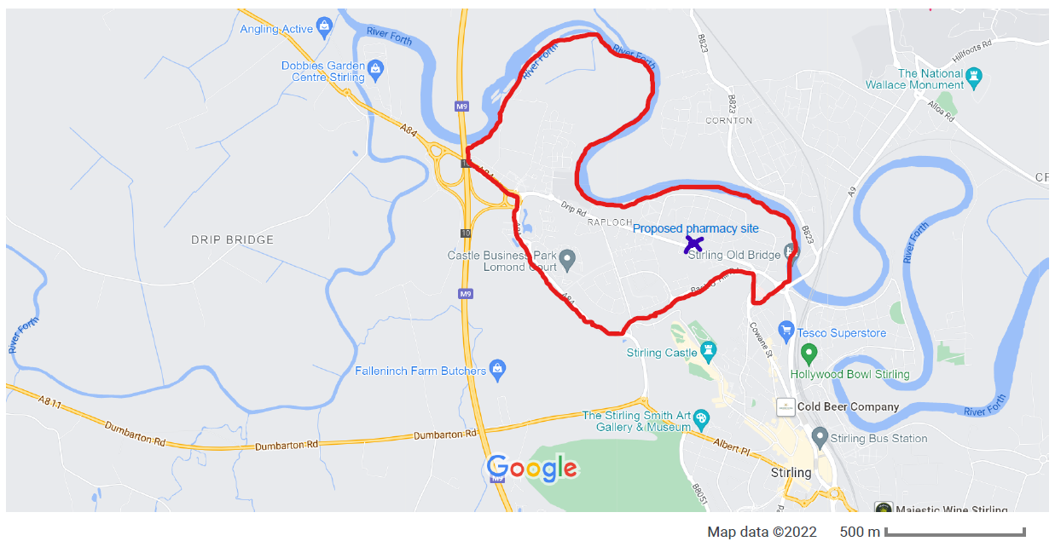

Further Comments

Page 4

