Learning, Education & Training Centre | NHS Forth Valley  Learning Centre  3rd Floor  Forth Valley Royal Hospital  Larbert  FK5 4WR  http://www.nhsforthvalley.com/
 | Enquiries to | Learning Education & Training Team
 | Direct Line | 01324 567388
 | Email | fv.school-placement-requests@nhs.scot

Dear Pupil,

Thank you for enquiring about a School Work Experience Placement at Forth Valley Royal Hospital, Larbert. Please find enclosed an application form.

Please complete the entire form, obtain the appropriate signatures, and return the form with a passport size photograph to your school’s work experience co-ordinator who must return them plus a covering letter to the NHS Forth Valley School Placements team at:

fv.school-placement-requests@nhs.scot

Please ensure you provide us with a valid email address that you regularly check, as all further communications to arrange your placement will be done with you via email.

There are certain departments that do not accommodate school students on placement. They are:

Women & Children
Paediatrics
ICU

If you have any questions regarding the application, then please contact us on the email address noted above.

Yours sincerely,

Linda

Linda Kirkwood
Learning Education &Training Team

Application for a school placement

First Name: Last Name:
Home Address:

Email (this is our primary method of communications)
Telephone Mobile:
Date of birth:
Next of kin: Relationship:
Emergency Contact No, where you can be reached during the day:
1: 2:
School:
Year: Applying to UCAS in the next 6 months? NO YES
Schools Address:
Work Experience Co-ordinator:
Email;
Telephone:

Placement Timetable
Please choose your THREE preferred days from the selection below and list your preferred department for each day. We endeavour to provide you with TWO days of work experience.
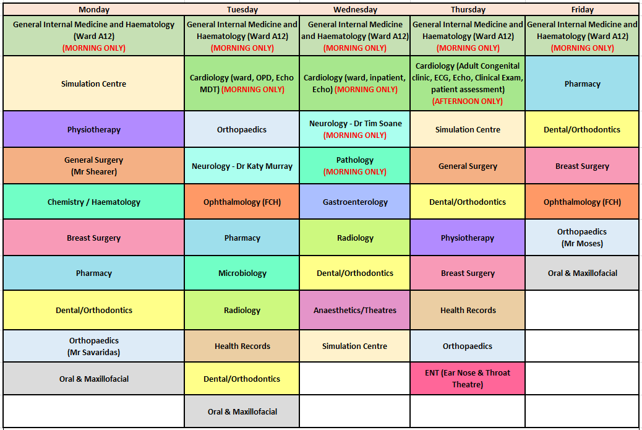

Day | Department Choice
Monday (EXAMPLE) | Physiotherapy (EXAMPLE)

☐ Please tick this box if you have a strong preference for a placement in the Emergency Department over and above any of the other departments listed in the timetable.

Emergency Department placements are dependent on staff availability and service demands and may not always be possible. If you indicate a strong preference for the Emergency Department, we will be in touch to discuss this with you.

Supporting information

This is your opportunity to promote yourself, to identify why you would like to gain a school placement within the NHS. Please use this space to provide any supporting information to go with your application. Supporting information can be anything that is not already covered by the questions on the form and may include any hobbies, interests, or other activity either within or outside of school which you enjoy (continue on a separate sheet if necessary):

Health

Please detail any health condition that you feel might have an effect on your school placement within NHS Forth Valley, i.e. allergies, asthma etc

Student, parent/guardian, and teacher agreement to NHS Forth Valley requirements

1. NHS Forth Valley places considerable importance on the need for attention to health and safety at work. You have the responsibility to acquaint yourself with the safety rules of the workplace, to follow these rules and make use of facilities and equipment provided for your safety. It is essential that all accidents, however minor, are reported.
2. NHS Forth Valley will also expect you to observe other rules and regulations governing the workplace which are drawn to your attention. Please note that there is a no smoking policy covering the whole working environment and that there are security arrangements applicable to most locations.
3. NHS Forth Valley fully supports equal opportunities in employment and opposes all forms of unlawful or unfair discrimination on the grounds of ethnic origins, gender, disability, age, religion, or sexuality. However some of the placements available carry an age restriction due to the nature of the work involved
4. There will not be payment for meals or travelling expenses.

I have read and understood the above requirements.
A passport style photograph and all signatures MUST be obtained prior to submitting the application.

Student
Signature:
Print name: Date:

Parent/guardian

I have read and understood the above requirements. I will ensure the student carries out these obligations and confirm that he/she is not suffering from any complaint, which might create a hazard to him/herself or to those working with him/her. I give permission for my son/daughter to attend the placement within NHS Forth Valley.

Signature:
Print name: Date:

Teacher/careers adviser

I have read the placement application and give permission for to attend the placement during his/her visit to NHS Forth Valley. I also confirm that he/she is currently studying at:
______________________________________________

Signature:

Print name: Date:

Email;

Please return this form to your work experience co-ordinator at your school. The school must then forward the completed form, passport size photo, plus a covering letter to fv.school-placement-requests@nhs.scot

