Referrals to be completed by a Registered Healthcare Professional

Incomplete or illegible referrals will result in a delay and will be returned

Have you consulted the Wound Management Formulary for advice in the first instance?
Wound Management Formulary or Tissue Viability Website Tissue Viability – Departments A-Z (scot.nhs.uk) or NHS Forth Valley – Tissue Viability

* PLEASE ATTACH WOUND PHOTOGRAPHS AS APPROPRIATE TO THIS REFERRAL (if not available on Morse)

SEND FULLY COMPLETED REFERRALS TO: fv.tissueviability@nhs.scot

PATIENT INFORMATION |  | Date:
Name: |  | D.O.B:
 |  | CHI:
Address & postcode:
G.P. Name & Address: |  | Consultant:
Referrer’s details or person to contact with regards referral
Name:
Contact Number:
Email Address:
Base:
Role:

Reason For Referral to TVS:
PMH:  - REASON FOR ADMISSION: If an inpatient in acute /community hospital |  | MEDICATION and any ALLERGIES please list  (TVS are unable to access Hepma)
Is the patient aware of the referral?
If no, please state why.

Any Risk to staff?

WOUND DETAILS
WOUND TYPE (e.g. trauma, orthopaedic, surgical wound, dehisced wound, haematoma, skin tear):

WOUND DURATION?: WEEKS- MONTHS- YEARS-

Anatomical Location:
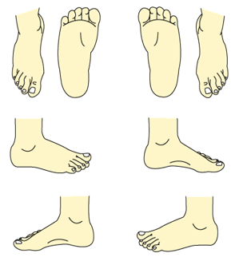
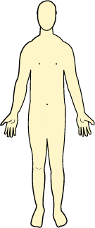
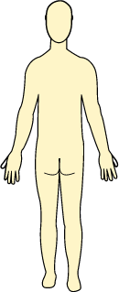
Please mark the position on the body map below

WOUND DIMENSIONS (CM/MM) |  | Length |  |  |  | Width |  |  |  |  | Depth
WOUND BED TISSUE  Complete in % |  | Necrosis/black |  |  |  | Slough/yellow
 |  | Granulation/red |  |  |  | Epithelialising/pink
 |  | Hypergranulation |  |  |  | Any undermining tracking?  Length/ depth (mm)
EXUDATE LEVEL  NHS Forth Valley Exudate Pathway | Saturated/leaking |  |  | Wet |  |  |  |  | Dry/moist
EXUDATE TYPE  NHS Forth Valley Exudate Pathway | Clear/  Straw |  | Red/pink | Cloudy/milky/creamy |  |  | Green/yellow/  Bluish?? |  |  | Yellow/brown
ANY CLINICAL SIGNS OF INFECTION? | If yes  List them: |  |  | Has a swab been taken for culture? |  |  | When: |  |  | Result:
PAIN PRESENT? NOCICEPTIVE? OR NEUROPATHIC? | Scale: 0 1 2 3 4 5 |  |  | Current Pain Management?
NUTRITION:  WEIGHT: KG  MUST SCORE:  BMI: |  |  |  | Current Nutrition Management?
MOBILITY :
Full:
Restricted:
Immobile: bed/chair /wheelchair bound
any walking aids:

State present wound treatment regime and how long in use:

Past wound treatments as applicable:

What is the patient’s attitude/behaviour towards their current treatment/management?

Any Referrals to Other Services as Applicable? | Dates
Orthotics
OT
Physio
Podiatry
Vascular
Dermatology
Other e.g. Dietician, wheelchair service

