Referrals to be completed by a Registered Healthcare Professional

Incomplete or illegible referrals will result in a delay and will be returned.

Have you consulted the Wound Management Formulary for advice in the first instance?
Wound Management Formulary or Tissue Viability Website Tissue Viability – Departments A-Z (scot.nhs.uk) or NHS Forth Valley – Tissue Viability

FV Compression Guidance Booklet (Wet legs and chronic oedema treatment algorithm)

* PLEASE ATTACH WOUND PHOTOGRAPHS AS APPROPRIATE TO THIS REFERRAL (if not available on Morse)

SEND FULLY COMPLETED REFERRALS TO: fv.tissueviability@nhs.scot

Patients who are referred for leg ulceration should have had a full Leg ulcer assessment and if appropriate ABPI (ankle brachial pressure index) performed within the last 12 weeks with sounds documented and recorded in referral.
PATIENT INFORMATION |  | Date:
Name: |  | D.O.B:
 |  | CHI:
Address & postcode:
G.P. Name & Address: |  | Consultant:
Referrer’s details or person to contact with regards referral
Name:
Contact Number:
Email Address:
Base:
Role:

Reason For Referral to TVS:
PMH:  - REASON FOR ADMISSION: If an inpatient in acute /community hospital |  | MEDICATION and any ALLERGIES please list  (TVS are unable to access Hepma)
Is the patient aware of the referral?
If no, please state why.
Any Risk to staff?

How long has the patient had the leg ulcer and or wet leaky legs?

NB If a wound has been present on lower limb
for more than 2 weeks – it is a leg ulcer
Left Leg Right Leg
Is this a recurrent ulcer? | Yes No

PLEASE ATTACH A PHOTOGRAPH OF THE WOUND TO REFERRAL (if not on Morse)
Anatomical Location:
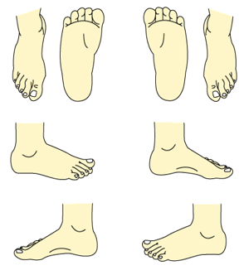
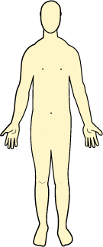
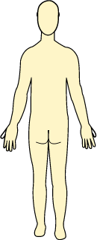
Please mark the position on the body map below

WOUND DIMENSIONS (CM/MM) |  |  | Length |  |  |  |  | Width |  |  |  | Depth
WOUND BED  Complete in % |  |  | Necrosis/black |  |  |  |  |  |  | Slough/yellow
 |  |  | Granulation/red |  |  |  |  |  |  | Epithelialising/pink
 |  |  | Hypergranulation |  |  |  |  |  |  | Any undermining tracking?  Length/ depth (mm)
EXUDATE LEVEL  NHS Forth Valley Exudate Pathway | Saturated/Leaking |  |  |  |  |  | Wet |  |  |  |  |  | Dry/Moist
EXUDATE TYPE  NHS Forth Valley Exudate Pathway | Clear/  Straw |  |  | Red/Pink |  |  | Cloudy/milky/creamy |  |  | Green/Yellow/  Bluish |  |  | Yellow/brown
ANY CLINICAL SIGNS OF INFECTION? | If yes  List them: |  |  |  |  |  | Has a swab been taken for culture? |  |  | When: |  |  | Result:
PAIN PRESENT? NOCICEPTIVE? NEUROPATHIC? | Scale: 0 1 2 3 4 5 |  |  |  |  |  | Current Management of pain?
NUTRITION:  WEIGHT KG  MUST SCORE:  BMI: |  |  |  |  |  |  | Current Management of any nutritional issues?
OEDEMA: |  | Yes No |  |  |  |  | Pitting  Fibrotic
SKIN CONDITION  Please describe: |  |  |  |  |  |  | Current Management of skin condition:
MOBILITY:  Fully  Restricted  Immobile/Bedbound |  |  |  |  |  |  | Is the patient sleeping in bed at night  YES NO  Are they elevating legs during day  YES NO
Any Other Comments:

Please refer to: Forth-Valley-Compression-Booklet.pdf (scot.nhs.uk)
Type of Leg ulcer
If known: Venous Arterial Mixed
Pedal Pulse palpable: Yes No
Pedal pulse sounds  (Monophasic, Biphasic, Triphasic) |  |  |  |  | Right |  |  |  | Left
Brachial
Dorsalis Pedis
Posterior Tibial
ABPI results:  Date: |  |  |  |  | Right |  |  |  | Left
Any type of Compression Therapy commenced:
Date commenced:
Any comments

What is the patient’s attitude/behaviour towards their current/treatment/management?

What previous management or involvement with other Services has there been? (eg specialist hosiery clinic, Lymphoedema)?

