NB Any patient’s with Diabetes presenting with heel/foot pressure ulcers should be referred urgently to Specialist Podiatry.

Referrals to be completed by a Registered Healthcare Professional

Incomplete or illegible referrals will result in a delay and will be returned

Have you consulted the NHS FV Illustrated Care plans for each grade of Pressure Ulcer?
Tissue Viability – Departments A-Z (scot.nhs.uk) or NHS Forth Valley – Tissue Viability

Pressure Ulcer Risk Assessment and Prevention Guide

Have you consulted the Wound Management Formulary for advice in the first instance?
Wound Management Formulary or Tissue Viability Website
Tissue Viability – Departments A-Z (scot.nhs.uk) or NHS Forth Valley – Tissue Viability

* PLEASE ATTACH WOUND PHOTOGRAPHS AS APPROPRIATE TO THIS REFERRAL (if not available on Morse)

SEND FULLY COMPLETED REFERRALS TO: fv.tissueviability@nhs.scot

PATIENT INFORMATION |  | Date:
Name: |  | D.O.B:
 |  | CHI:
Address & postcode:
G.P. Name & Address: |  | Consultant:
Referrer’s details or person to contact with regards referral
Name:
Contact Number:
Email Address:
Base:
Role:

Reason For Referral to TVS:
PMH:  - REASON FOR ADMISSION: If an inpatient in acute /community hospital |  | MEDICATION and any ALLERGIES please list  (TVS are unable to access Hepma)
Is the patient aware of the referral?
If no, please state why.
Any Risk to Staff?

PRESSURE ULCER DETAILS
DURATION?: WEEKS- MONTHS- YEARS-

Admitted to hospital with PU - Yes/ No | Hospital Acquired PU – Yes/No
Has IR1 been completed?:
GRADE: Please see grading tool: Grade 3 Grade 4 SDTI Ungradable
Scottish Adaptation of the European Pressure Ulcer Grading Tool
Has there been any previous pressure damage? When and Grade?

Name of Pressure Ulcer Risk Assessment Tool: | State Risk/Score:

Surface: What is the patient currently: | Sitting On? (bed/chair/riser  recliner/sofa etc) | Any pressure relieving Cushion:
 | Sleeping On? bed/chair/riser  recliner/sofa etc)  Offloading Heels? | Any Pressure relieving Mattress:
Skin Assessment | Is peri-wound skin intact Yes/No  Comments
Keep Moving | What is current repositioning regime?
Incontinence/ Moisture | Any current Issues?  State Management Regime:
Nutrition | Weight: MUST Score:  BMI:  Current Management as applicable:

Please list any posture or positioning problems, including concordance:

DESCRIPTION OF PRESSURE DAMAGE:

Anatomical Location:
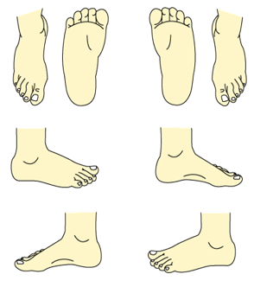
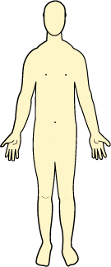
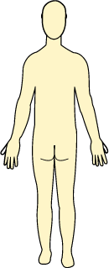
Please mark the position on the body map below

WOUND DIMENSIONS (CM/MM) |  | Length |  |  |  | Width |  |  |  |  | Depth
WOUND BED TISSUE  Complete in % |  | Necrosis/black |  |  |  | Slough/yellow
 |  | Granulation/red |  |  |  | Epithelialising/pink
 |  | Hypergranulation |  |  |  | Any undermining tracking?  Length/ depth (mm)
EXUDATE LEVEL  NHS Forth Valley Exudate Pathway | Saturated/leaking |  |  | Wet |  |  |  |  | Dry/moist
EXUDATE TYPE  NHS Forth Valley Exudate Pathway | Clear/  Straw |  | Red/pink | Cloudy/milky/creamy |  |  | Green/yellow/  Bluish?? |  |  | Yellow/brown
ANY CLINICAL SIGNS OF INFECTION? | If yes  List them: |  |  | Has a swab been taken for culture? |  |  | When: |  |  | Result:
PAIN PRESENT? NOCICEPTIVE? OR NEUROPATHIC? | Scale: 0 1 2 3 4 5 |  |  | Current Pain Management?
State present wound treatment regime and how long in use:

Past wound treatments as applicable:

What is the patient’s attitude/behaviour towards their current treatment/management?:

Any Referrals to Other Services as Applicable? | Dates
Orthotics
OT
Physio
Podiatry
Vascular
Dermatology
Other e.g. Dietician, wheelchair service

