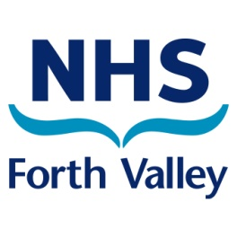
Community Food Activity
Grant Application Form

From April 2024 Grants are available from £50 - £400 for
Community Food Activities
Closing date: Monday May 27th 2024
- Name and address of Group/Organisation applying for funding:

- Name of person requesting the funding role within organisation:

- Email address and contact telephone number:

- How did you find out about the Community Food Grants? (allow multiple answers)
- Social Media
- Word of Mouth
- Colleague
- Newsletter
- Other

- Describe the Food activities that you plan to deliver?

- Do you currently charge for activities? Yes/No

- Please tick the areas where the activity will be delivered: Falkirk/Stirling/Clacks/Forth Valley Wide

- Please give an indication of the number of people who will benefit from this grant and activity?

- Will the project or grant benefit any of the following and if so, how?

Children and Young People |  | Adults with mental health issues
Adults |  | Adults with disability
Older adults |  | Adults with physical health issues
All age groups |  | Children & young people and their families/carers
BAME Groups |  | Alcohol and Substance Use Communities
LGBT |  | Domestic Abuse Communities
Refugees |  | Travelling Communities
People in Community Justice System |  | Other, please specify
Homelessness Communities
Please provide additional details here:

- Give details and names of any partners or groups involved with this project?

- How will this project be sustained after the funding has been spent?

- List all items to be purchased with the grant money and include the cost per item:

Items | Cost
Total cost:
(Remember to keep a copy of all receipts!)

- Please give details of any additional funding for this project:

- Which of the following does the organisation have in place? Constitution/Steering Group/ Management Committee

- Declaration - Signed on behalf of organisation/group name:
and authorised by:

- We (the group/organisation) have read and agree to abide by the conditions governing the award of the Community Food Activity Grant.

- We agree to submit a brief evaluation showing how the grant has been spent and the difference it made locally within 6 months of receipt of funds

- We agree that the details supplied in this form will be held on file by NHS Forth Valley

- Please tick the box to opt out if you do not wish this information to be shared with other departments within NHS Forth Valley

- Date:

Please complete all questions in this Application Form, save it then email as an attachment to fv.publichealthnutritionteam@nhs.scot

